

**REPORT ON DESIGN THINKING PROJECT**

# 

Subject : Technology and Information Systems (SECP 1513)

Section : 01

Name of Lecturer : Dr Azurah A Samah

Date : 30th November 2023

Title of Design : IntelliStep - Innovation of Shoe Sole

Thinking Product

Video Link (youtube): <https://youtu.be/bgEDMrIp2CQ?feature=shared>

**Group Profile**

| Name: **Balqis Nabilah binti Muhammad Azwan**  Matric Number: **A23CS0054**  E-mail: **balqisnabilah@graduate.utm.my**  Phone number: **012-9003494**  Course: **Computer Network and Security**  E-Portfolio:<https://github.com/baalqisnabilah> | Name: **Tay Ching Xian**  Matric Number: **A23CS0307**  E-mail: **tayxian@graduate.utm.my**  Phone number: **011-55024765**  Course: **Bioinformatic**  E-Portfolio: <https://github.com/Taychingxian> | Name: **Huwa Jia Sheng**  Matric Number: **A23CS5005**  E-mail: **huwa@graduate.utm.my**  Phone number: **016-7176768**  Course: **Computer Network and Security**  E-Portfolio: <https://github.com/JustinHuwa> |
| --- | --- | --- |
| Name: **Seifeldin Taha Abdelrahim Tohami**  Matric Number: **A19EC3030**  E-mail: **shashameme527@gmail.com**  Phone number: **011-27440914**  Course:  **Computer Network and Security**  E-Portfolio: <https://github.com/homahh> | Name: **Mathan Rao A/L Ramavijayan**  Matric Number: **A23CS0109**  E-mail: **mathanrao@graduate.utm.my**  Phone number: **013-8100585**  Course:  **Computer Network and Security**  E-Portfolio: <https://github.com/Mathan0702> | Name: **Hamdan Saleh Omar Al-Mohamadi**  Matric Number: **A22EC4027**  E-mail: **hamdan.saleh2003@gradute.utm.my**  Phone number: **017-2730164**  Course:  **Computer Network and Security**  E-Portfolio:<https://github.com/hamdan-saleh> |

Comments by Grader:

# 

# 

# 

# **CONTENTS:**

| **No.** | **Title** | **Page** |
| --- | --- | --- |
| 1. | Introduction | 5 - 6 |
| 2. | Detailed Step | 7 - 9 |
| 3. | Detailed Description | 10 - 12 |
| 4. | Design Thinking Assessment Point | 13 |
| 5. | Design Thinking Evidence | 14 - 18 |
| 6. | Reflection | 19 - 22 |
| 7. | References | 23 |

# **1.0 INTRODUCTION**

Design Thinking is considered as a process that seeks to solve complex problems by approaching it from the user’s perspective. It is less linear but more iterative as people will discover new things that require them to repeat certain steps of the process. The Design Thinking Framework can be drilled down into three distinctive phases, which are immersion, ideation and implementation. This framework can then be broken down into five stages which make up the Design Thinking Process, that is Empathise, Define, Ideate, Prototype and Test.

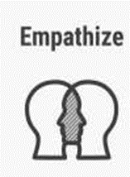

|  | In this stage, people are required to understand the target audience and have a real and various insight into the users’ needs, thus painting a clear picture of who their end users are, what challenges they face, and what needs and expectations must be met. This can be achieved by conducting surveys, interviews, and observation sessions to know how they think, act and feel. |
| --- | --- |
|  | Then, define the problem. Analyzing and synthesizing the problems is important to define the core problems that have been identified by the team. Thus, a discussion was conducted to identify the problems faced by users and define a problem statement. The problem statement will act as a guide for people to focus on solving the problem instead of trailing off the topic. |
|  | Instead of having your thoughts fixed on something, start brainstorming to produce solutions which meet users’ needs. Look things in a different angle and discover new solutions such as bodystorming, reverse thinking and even collaborating with other groups, before narrowing down to the best solutions. |
|  | Prototypes are types of “scaled down” versions of solutions for the problem statement after narrowing down to few solutions. The prototypes are created by having a clear goal in mind and easy to understand. It can be any shape, size or media, but the key is to be tangible and can be tested on users. |
|  | Lastly, test the prototypes by choosing volunteers and ask for reviews. After that, decide if the prototypes are valid or if any improvements are required. Therefore, people should redefine the original problem statement or come up with new ideas you hadn’t thought of before. |

(Table 1: 5 stages of Design Thinking)

# 

# **2.0 DETAILED STEP**

On 23 October 2023, we were given a task about solving problems in our daily life through design thinking. We found out that shoes nowadays are becoming more and more popular as it is considered as a basic need in our daily life. Despite the growing number of shoe brands and shoes, many people were unhappy with their shoes due to their shoes being uncomfortable to wear. This is mainly because shoe soles lack certain characteristics causing shoe soles cannot reduce pressure and cushion the feet. So, we decided to use the design thinking process to solve the problem.

**Empathize**

We started the empathize process by interviewing different people. We found out that most people nowadays buy shoes without much consideration for things such as where they will be wearing them, how often they will wear them, and the type of shoes that they should wear. As a result, they ended up spending money on unnecessary shoes instead of suitable shoes. Most teenagers that have little sense of consumer awareness will spend money on shoes that look nice or shoes that have a famous brand without considering their shoe soles material, durability, and budget. Furthermore, some people that wanted to save money ended up buying shoes that are either inappropriate to wear or have shoe soles that are too hard or too thin. As a result, they ended up burdening their feet and causing injuries such as aching arches, blisters and even causing irreversible effects on the feet.

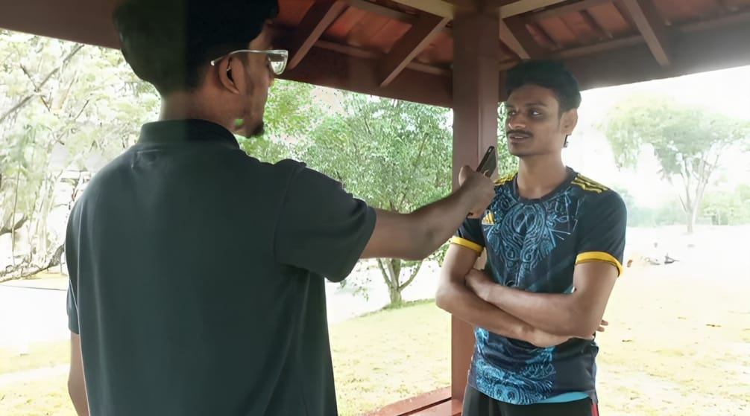

*( Diagram 1 : Face-to-face interview with people who had issues with their shoes )*

**Define**

After the empathize process, we started our research on shoes and the types of shoe soles. We gathered all our findings through various aspects such as books, websites, and observation sessions to learn about the types of shoe soles favored by the society. We found that most people felt uncomfortable with their shoes mainly because of the shoe soles. Most of the shoe soles nowadays are mainly made from rubber, causing their shoes to be too heavy or having exerted too much pressure due to the shoe sole being too thin. So, we decided to make a problem statement, which is the importance of shoe soles in daily life. Through our research, we defined three problem statements based on three different groups, which are athletes, elderly, and the general society.

The three problem statements are:

1. How does the shoe sole contribute to an athlete’s performance during training or competition?
2. What kind of characteristics do you look for in shoe soles now, and has that changed as you've gotten older?
3. What are the factors that influence your decision when purchasing shoes?

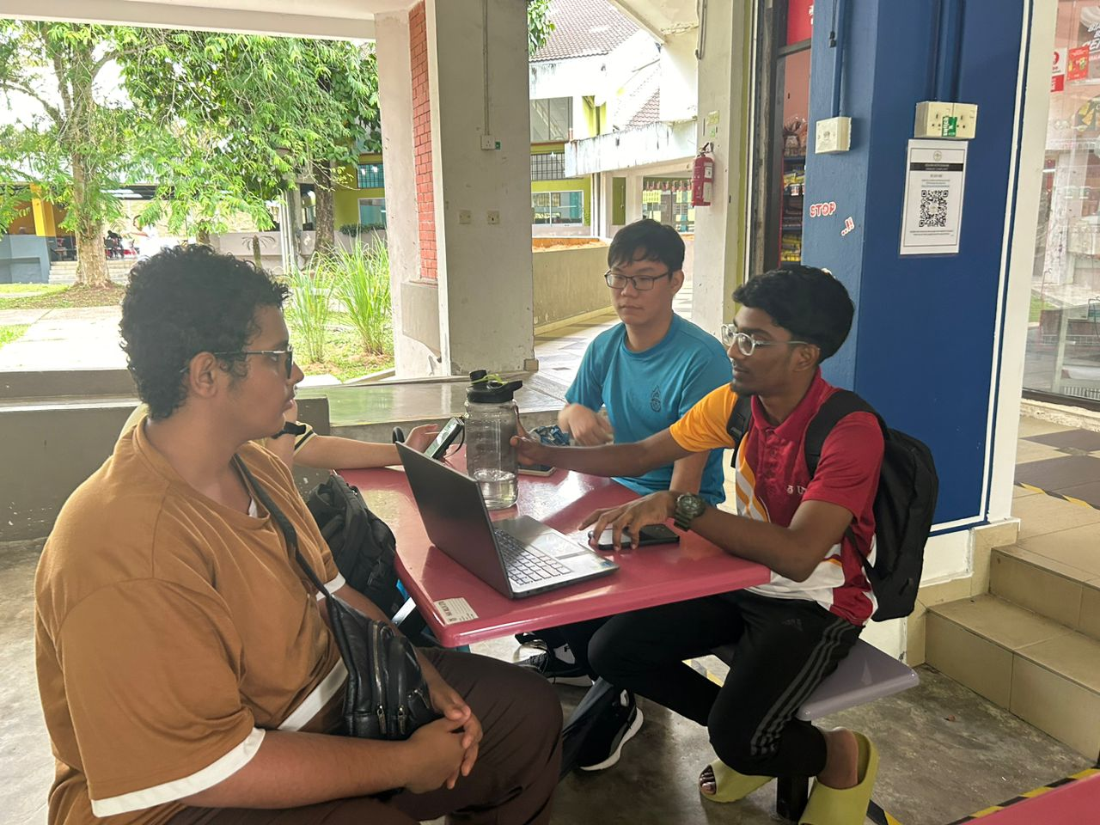

*( Diagram 2: Gathering all the findings after empathize phase)*

**Ideate**

After the problem statements are clearly framed, we started to search for solution methods through brainstorming, mind-mapping and bodystorming. We tried to explore as many solutions as we can to come out with the best to handle the problems faced by the users. After that, we shortlist the best solutions for the problems and leave the rest to try to produce a good prototype for our users. These are the examples of the solutions such as our shoe sole that has a firmer grip, has breathable characteristics and great cushioning. Besides, it is also weather resistant to climate changes and extremely durable to natural tractions.

**Prototype and Test**

After we got the solutions, we started to bring out the solutions into version by design specific shoe soles. We created a rough prototype named IntelliStep. We also created different types of shoe soles to identify which of them is favoured by society. By putting in the solutions to the test and highlighting any constraints and flaws. In our prototype, we create two phases, one is for common people who use shoe soles for regular use such as walking and the other for athletes which specify in certain sports. In phase one, we let the common people wear our prototype and test it in daily life activities. The common people liked our creative thinking with the design and breathable characteristics. In phase two, we let the athlete use our prototype in training, and they were quite satisfied as their arch pain has been relieved. Though, we also receive some criticism like the shoe soles being too light, having too much glue or the design is too unfriendly according to their own preferences. So, our prototype became a huge success due to the overwhelming support and appreciation.

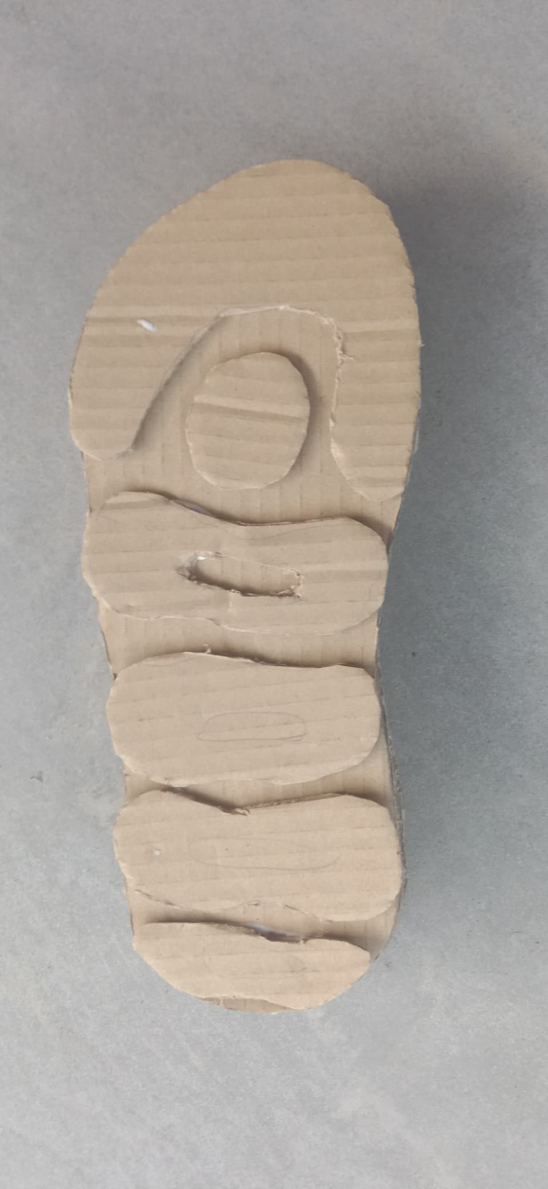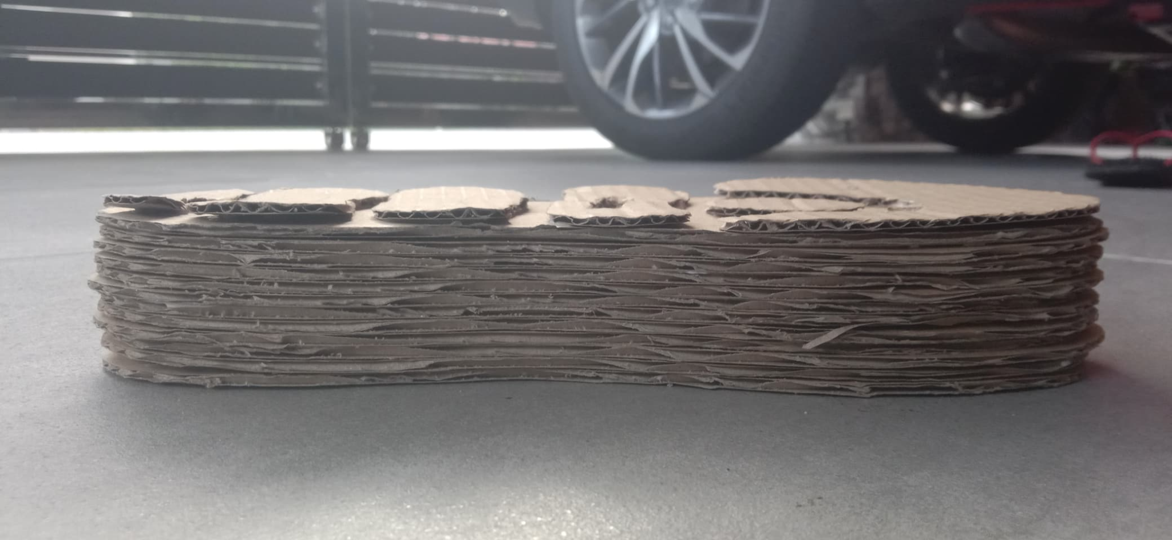

*( Diagram 3: Prototype for shoe soles)*

# **3.0 DETAILED DESCRIPTION (PROBLEM, SOLUTION AND TEAM WORKING)**

**Problems**

1）Style Over Function:

* Certain trendy shoes may not offer enough support or comfort .
* Some materials used in fashion might not be as long-lasting as those practical usage.

2) Comfort Issues(sizes):

* Many shoes don't provide enough arch support, which can cause pain and even cause foot issues.
* Uncomfortable shoes can lead to blisters, and other foot problems.
* Lack of cushioning can cause discomfort, especially during activities that involve impact, like running or walking on hard surfaces.

3) Cost:

* Cost isn’t equal to quality of shoes.

4) Health Concerns:

* Certain fashion trends may lead to shoes with high heels or narrow toe boxes, contributing to foot pain and potential health issues.
* Soles that wear out quickly can lead to discomfort and may require frequent replacement.
* Incorrect pronation (overpronation or underpronation) can lead to foot and leg pain.
* Insufficient arch support can lead to discomfort and foot fatigue.

5) Durability:

* Some shoes are made with lower-quality materials, leading to faster wear and tear.
* Soles that wear out quickly can affect the overall lifespan of the shoe.
* Soles that are too stiff or too soft can cause discomfort or lack of stability.

**Solutions**

* Look for shoes with built-in arch support or consider using orthotic insoles to provide additional support.
* Measure your feet regularly and try shoes on before purchasing. Brands may have different sizing standards, so finding the right fit is crucial.
* When acquiring and choosing raw materials, producers should apply strict quality standards.
* Research reviews and brand reputation before purchasing. Consider the overall value, including durability and comfort, rather than focusing solely on price.
* Don’t just prioritize the appearance and brand of the shoes before we buy it,we should consider more.
* Prioritize foot health over fashion trends. Choose shoes that provide proper support and comfort, and limit the use of high heels or shoes with narrow toe boxes.
* Choose shoes made from high-quality materials. Research brands known for using durable materials and good craftsmanship.
* Choose shoes with stronger soles or have more resilient insoles in place of the current ones. To minimize wear on certain pairs, rotate your shoes on a regular basis.

**Team Working**

Physical Meeting

1. Date: 21/11/2023
2. Meeting location: M01, Kolej Tun Dr. Ismail
3. Meeting start/finish:

* Start: 3:00 pm
* Finish: 4:30 pm

1. Agenda:

* Discuss problem we faced
* Find solution and gather idea

1. Evidence:

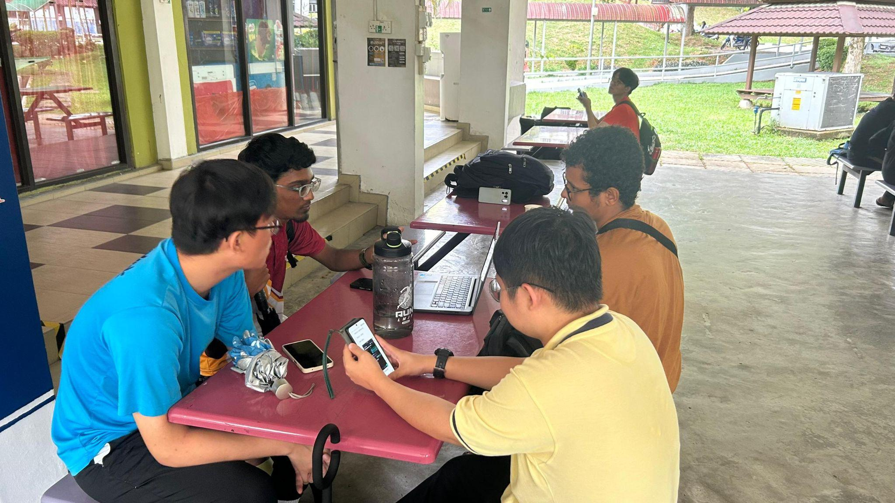

Online meeting

1. Date: 22/11/2023
2. Attendance: (6/6)
3. Meeting location:

* Host: Mathan Rao A/L
* Link: <http://meet.google.com/tyj-hpxh-qhd>

1. Meeting start/finish:

* Start: 9:00pm
* Finish:10:00pm

1. Agenda:

* Discuss about video making
* Discuss about interviewing

1. Meeting recorded by: Hamdan Saleh Omar Al-Mohamadi
2. Evidence:



# 

# 

# **4.0 DESIGN THINKING ASSESSMENT POINT**

**During the end of the project demonstration**

At the conclusion of our project, our team holds up great. We helped each other though we divided our parts and everyone worked very hard to complete the project. We learn that design thinking is a process of problem solving in all aspects of our life. Besides that, we know that developing a shoe sole was no easier because we need to satisfy each design thinking phase. For our next phase, we are going to develop our shoe sole and for the future we will include some more features to our shoe sole to satisfy the customers.

**During the transition between design thinking phases**

At the transition phase, we face many types of problems which we do not have any idea and solution to solve the problems that the customers are facing. We also have some disagreement during the discussion due to different ideas but we discuss together and choose the most suitable solutions. During every phase of design thinking, we cooperate together to discuss and solve the issues we face.

# **5.0 DESIGN THINKING EVIDENCE**

1. Sample work
2. **Interview Session during Empathy phase**

# 

1. **Physical and Online meeting during Define and Ideate phase:**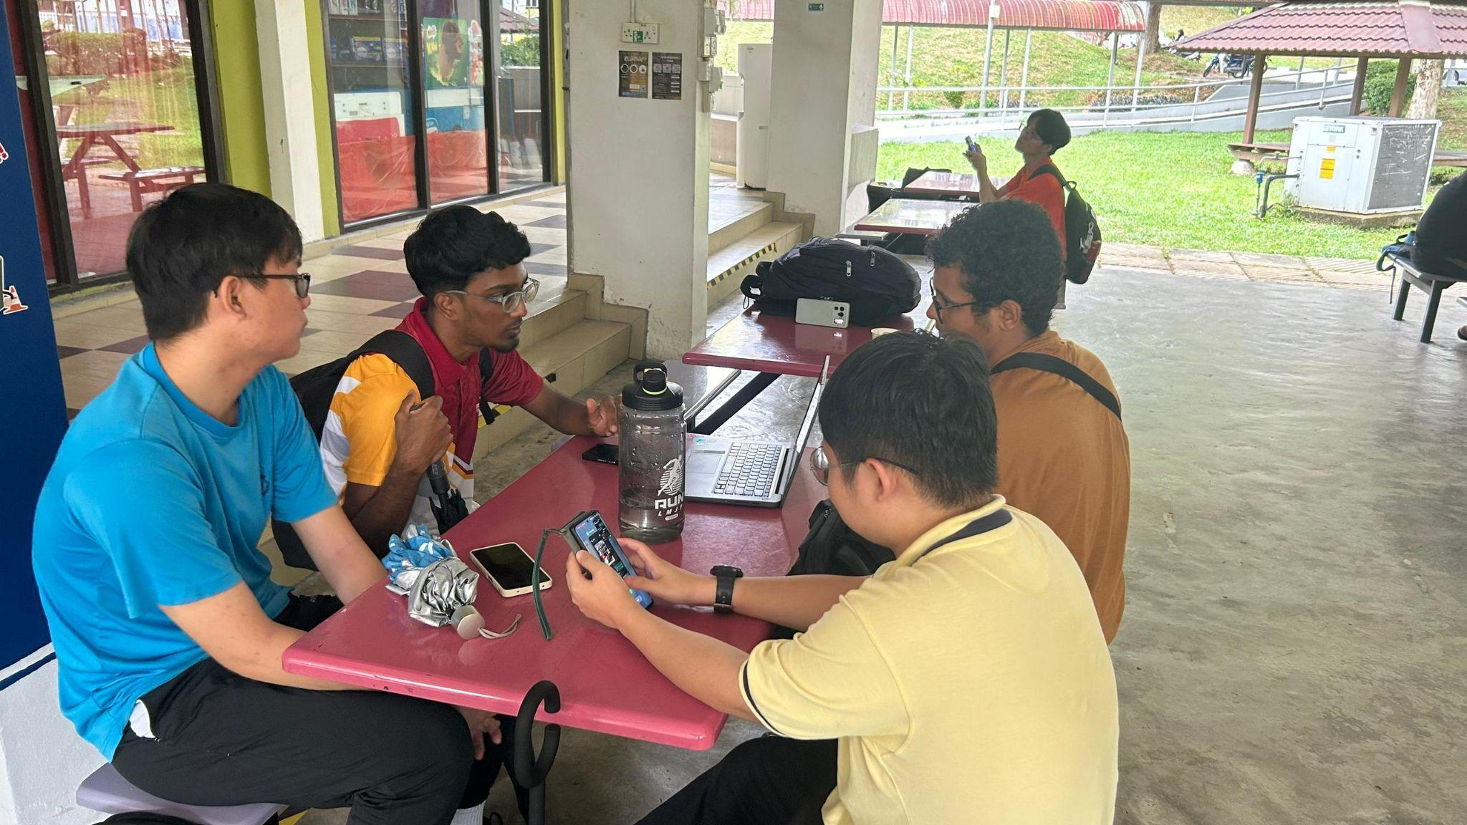



1. **Prototype phase**

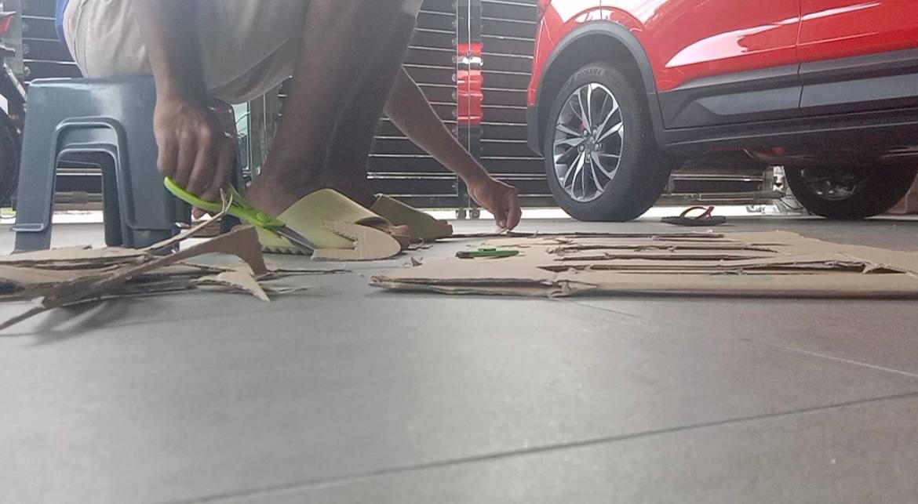

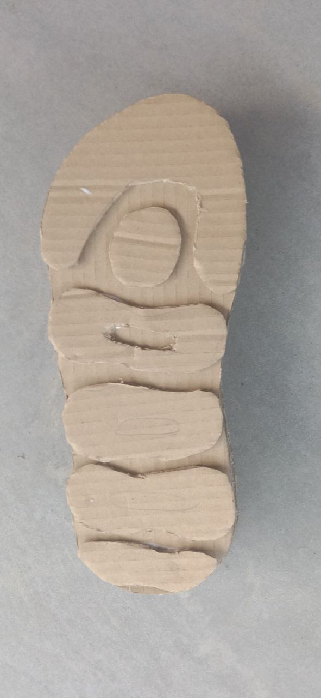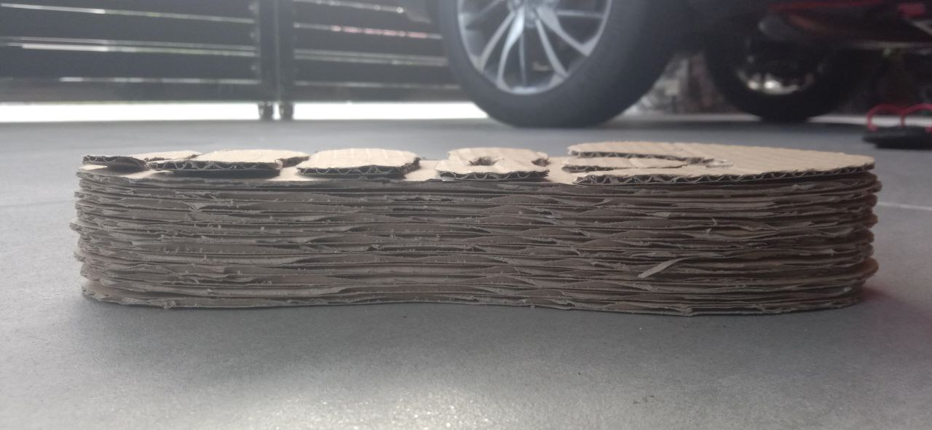

1. **Testing phase**

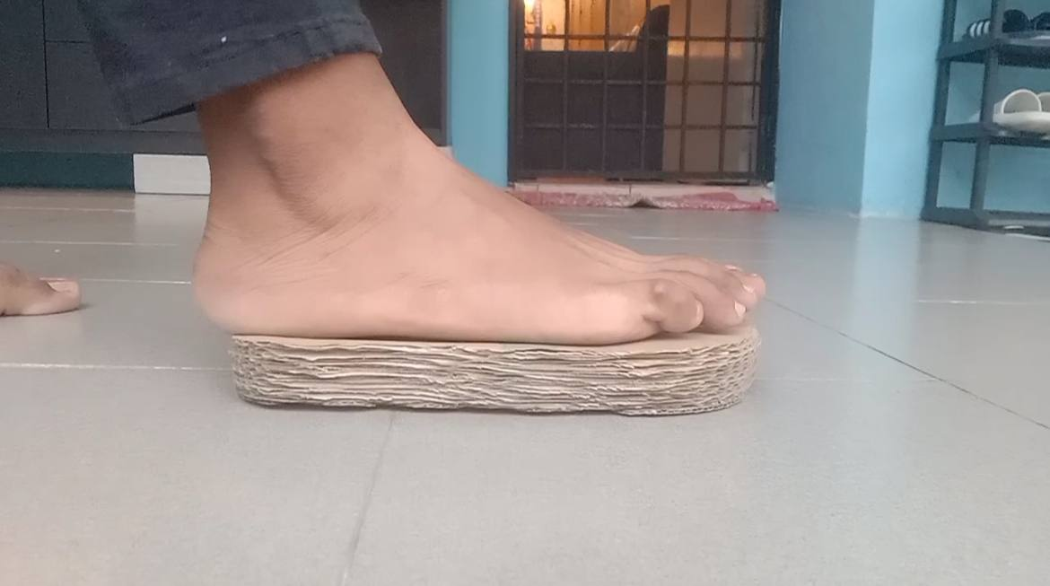 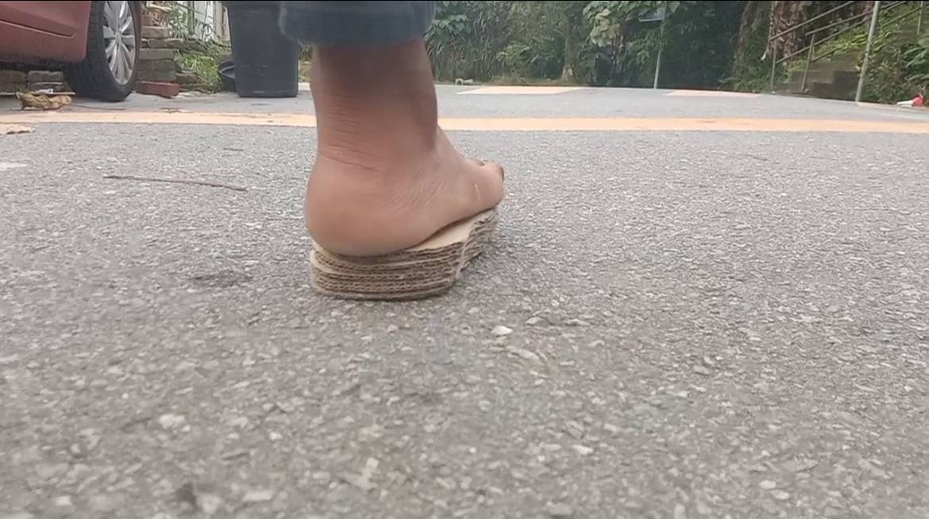

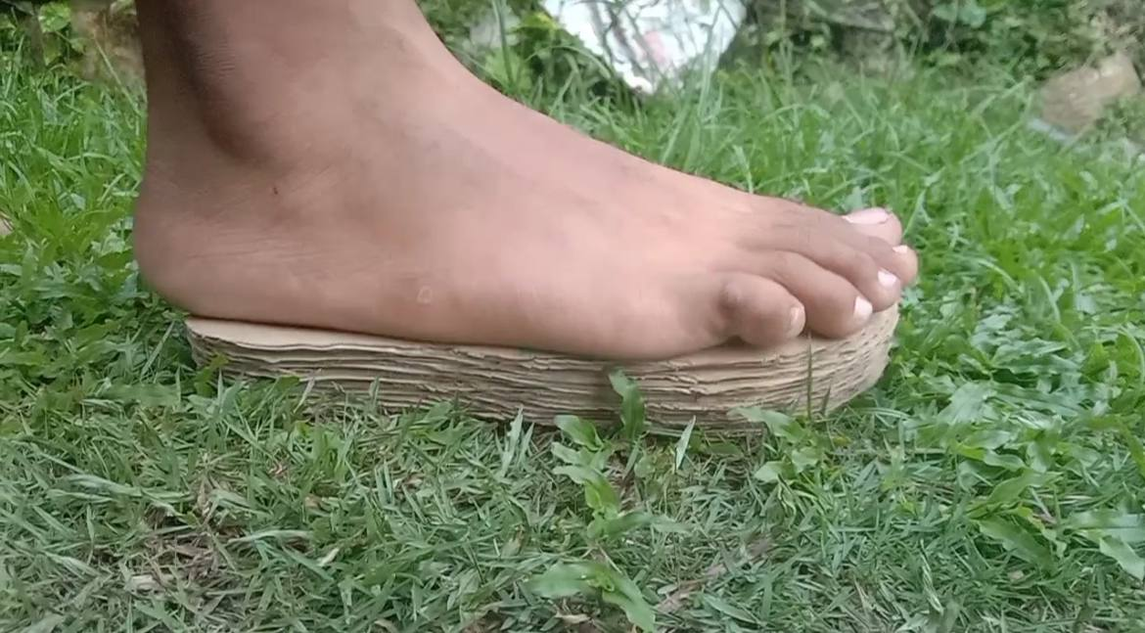

1. **Record for each phase**
2. **Empathy**

The table below are the questions and the answer during the interview sessions

Interviewee 1:

| Name | Tishen A/L Santhiragasan |
| --- | --- |
| Occupation | Student |
| Field | Degree in Computer Network and Security |
| What do you think about your shoe sole and how does the shoe sole contribute to an athlete’s performance during training or competition? | The condition of my shoe sole is concerning. A well maintained shoe sole is crucial for an athlete's performance as it provides support and comfort. I think my shoe sole condition right now can lead to potential injuries due to reduced grip. |

Interviewee 2:

| Name | Mohammed Al-Amrani |
| --- | --- |
| Occupation | Student |
| Field | Phd in Electrical Engineering |
| What kind of characteristics do you look for in shoe soles now, and has that changed as you've gotten older? | To be comfy and made of light materials and also to look good, honestly it didn't change as I've gotten older. I still look for the same characteristics in a shoe sole. |

1. **Define**

Table below shows the problem faced by the user.

| **Problem** | **Probable Solution** |
| --- | --- |
| Lack of cushioning and insufficient arch support | Shoes sole with built-in arch support and sufficient cushioning |
| Look into shoe soles for all ages and activities | Consider the varying flexibility needs of adults and seniors. |
| Soles that are too stiff or too soft | Choose shoes made from high-quality and durable materials |

1. **Ideate**

* Date: November 23, 2023
* Exercise: Mind mapping, bodily mapping, and brainstorming sessions.
* Brainstorm Process: The group looked into ways to make the shoe soles more cushioned, more breathable, and better gripped.
* Proof:

1. **Prototype**

* Date: November 23, 2023
* Activity: Developing several styles of shoe soles and building an IntelliStep rough prototype.
* Development of the Prototype: The group created IntelliStep, a prototype shoe sole that has better cushioning, breathability, and traction.
* Evidence:

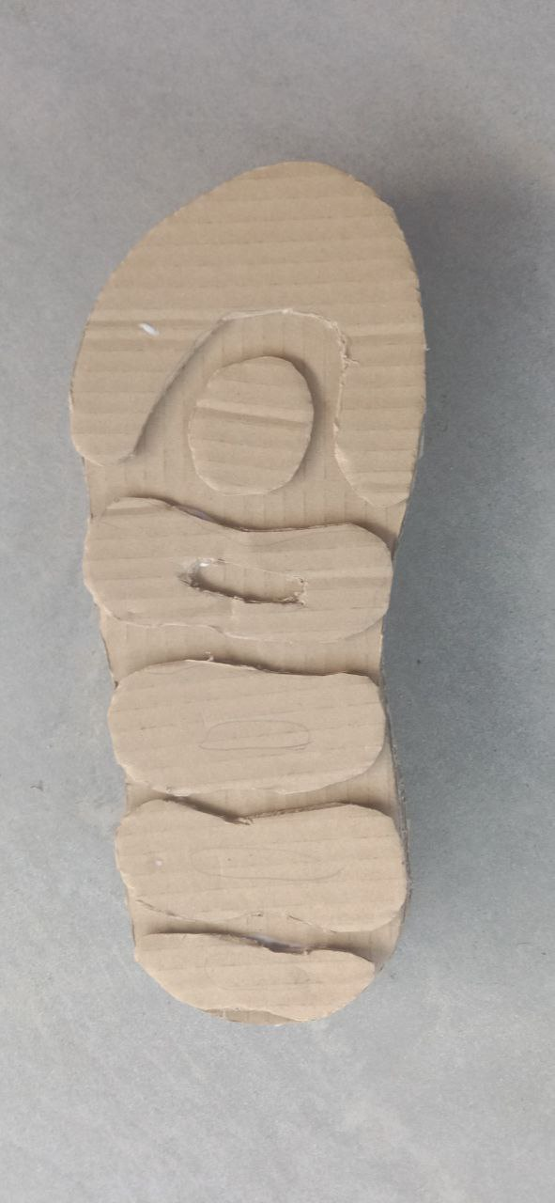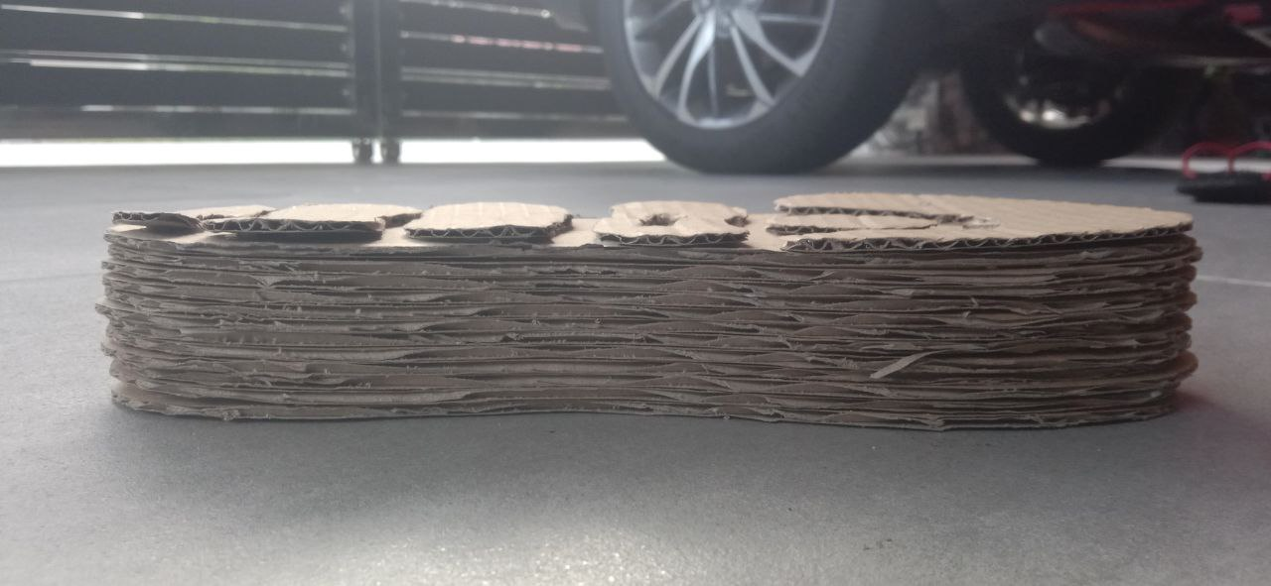

1. **Test**

We tested the prototype on three different surfaces which are roads, grass, and tiles. The variation in pressure is due to the differences in the surface texture, hardness, and composition. For instance, on a hard and smooth surface like a road or tile, the pressure might be more concentrated, while on softer surfaces like grass, the pressure tends to distribute more due to the material's ability to compress. This impacts how much the shoe sole sinks in or grips the surface, affecting stability, and comfort.

# 

# **6.0 REFLECTION**

| **GROUP MEMBERS** | **ANSWERS** |
| --- | --- |
| Balqis Nabilah binti Muhammad Azwan | 1. In the current digital age, network and computer system security has emerged as the most crucial issue. Practically every sector revolves around the use of technology for information and data management. Thus, it is essential to preserve and defend the same. This motivated me to learn more and advance my expertise in cybersecurity. I believe that this course will bring me closer to my ultimate goal of building a system that is safe and secure for every industry. 2. According to what I discovered while working on this project, design thinking has a big influence on my ability to solve problems in an organised and creative way. As design thinking promotes a holistic view of problems, considering both technical and human factors, I can learn how to approach security difficulties from a novel and human-centred perspective in cybersecurity practices. This will ultimately help to produce more comprehensive and effective security solutions. 3. As an improvement step, I need to stay informed and regularly read cybersecurity news, blogs, and industry reports about the latest threats, vulnerabilities, and best practices. In order to automate processes and evaluate security data, I will also improve my critical thinking abilities and learn more about programming languages like Python that are frequently used in cybersecurity. I'll also attend cybersecurity conferences and events to network with people in the field, learn from experts, and take part in seminars to stay up-to-date on industry trends. |
| Huwa Jia Sheng | 1. Regarding the course that I am currently studying, which is cyber security, my main goal is to become motivational in my studies and learn more about computing. Design Thinking can help me to have a further understanding about the concept and try out different ideas. 2. Throughout this project, I learnt that most of our problem solving situations nowadays involve Design Thinking. It also helped people to have a further understanding with steps involved before a specific product is created. By using the Design Thinking method in projects and creating various prototypes, we managed to learn solving problems from different perspectives and creating prototypes before the actual product is released, which can help people to be concise with their topic and spend less effort on wasting time creating irrelevant things. 3. As a conclusion, I learned that Design Thinking has played a major role in our daily life and understand our specific skills throughout this project. Therefore, I decided to attend different computing courses to have a further understanding about cyber security. I also hope that I can develop an interest in cyber security and improve my computing skills in the future. |
| Tay Ching Xian | 1. As a student of computer science, my goal is to use the information system to benefit society. I have a strong desire to create something innovative that would improve people's quality of life. Design thinking gives me an opportunity to work toward my goal. I appreciate it a lot. 2. Design thinking taught me a lot of things. First of all, I had developed my ability to work with people. Even though we acquired knowledge in the classroom, soft skills remain one of the most crucial aspects of our lives. I think that communication is essential. Second, I developed my problem-solving skills. Our ability to solve problems is really crucial.I have learned how to gather ideas from others and make a better decision. Lastly, it’s about responsibility and accountability. We all are taught to be accountable to the group as well as to accept accountability for the duties they are given. This cultivates a feeling of dedication and dependability. 3. In conclusion, design thinking taught me a lot. I'll keep honing my abilities in the future. In the future, I aspire to realise my dream of creating something useful for people. I value each and every one of my coworkers' contributions. |
| Mathan Rao A/L Ramavijayan | 1. Regarding the course I am studying, which is Computer Networks and Security, my goal is to become successful in this field and learn more about technology and information systems. I am passionate about cybersecurity. The increasing cyber threats have underscored the urgent need for skilled professionals who can safeguard digital assets. Also, my goal is not just to excel academically in my course but to apply the knowledge gained to make contributions to the field of Computer Networks and Security. 2. After getting involved in this design thinking project, it strengthened my goal and helped me to understand the ways to provide a solution based approach in solving real life problems. Throughout the process, I have learned to define and ideate the problem. By creating the prototype and testing it, I gained an insight on what is the job scope of cybersecurity. So, design thinking really helps me to understand the real problem and solve it in an efficient way. 3. In the future, to enhance my potential in the cybersecurity field, I will continuously learn and develop my skills. I hope engaging in a design thinking project will fortify my practical skills and problem solving abilities. So, by consistently staying updated and active, I aim to elevate my capabilities and make contributions to the cybersecurity sector. |
| Hamdan Saleh Omar Al-Mohamadi | 1. Participating in a design thinking project to create an innovative shoe sole unexpectedly mirrored my aspirations in Computer Networks and Security. Just as the meticulous process of designing a sole involves problem definition, ideation, prototyping, and testing, my academic journey in cybersecurity similarly requires comprehensive problem understanding and iterative solution crafting. 2. Design thinking reinforced my commitment not only to excel academically but also to contribute meaningfully to cybersecurity. The project provided practical insights into the field's holistic nature, emphasising the importance of a solution-based approach. 3. Looking forward, I am inspired to continuously enhance my potential by staying updated, engaging in projects, and honing my problem-solving skills. I believe that more design thinking initiatives will fortify my practical skills, enabling me to contribute significantly to the dynamic cybersecurity sector. 4. This unexpected connection between a shoe sole project and my academic and professional goals underscores the power of innovative thinking to transcend traditional boundaries and create meaningful parallels between diverse fields. |
| Seifeldin Taha | 1. As a participant in this creative shoe sole design thinking project, I discovered unanticipated connections between my academic and professional objectives in computer networks and security. The design of a sole was a complex process that involved brainstorming, problem characterization, prototyping, and testing. This methodical approach was similar to what was needed in the cybersecurity field. 2. I learned a lot about the comprehensive approach to cybersecurity problem-solving from this assignment. It emphasised how important it is to have a thorough grasp of problems and to create solutions repeatedly, which is consistent with the design thinking technique. My dedication to achieving academic success and making significant contributions to the cybersecurity profession has been strengthened by this experience. 3. I'm driven to reach my full potential going forward by keeping up with industry developments, taking part in initiatives actively, and honing. |

# **7.0 REFERENCES**

1. *The design thinking process | What it is, how to use it, and what’s next*. (n.d.). <https://www.invisionapp.com/inside-design/what-is-design-thinking/>
2. *What is Design Thinking?* (2023, November 17). The Interaction Design Foundation. <https://www.interaction-design.org/literature/topics/design-thinking>
3. Six common quality control problems in shoes and how to fix them | QIMA. (n.d.). [Www.qima.com](https://web.telegram.org/a/Www.qima.com).<https://www.qima.com/testing/footwear/common-shoe-problems>
4. Solutions to the Biggest Shoe Problems. (2014, September 22). Woman’s Day.<https://www.womansday.com/style/fashion/a7038/comfortable-shoes/>
5. Five common shoe defects and solutions – Eurofins. (n.d.). Eurofins Scientific. Retrieved November 30, 2023, from<https://www.eurofins.com/assurance/consumer-products/resources/articles/five-common-shoe-defects-and-solutions/>